1. For all forms the Arabic names fields: “should not be required to fill”
2. When Page Saved a new account is created in the name of the bank and branch under Current Assets.

Ok but should be saved under CASH inside Current Assets “ not Others”

* In account chart when add new account and add account balance:

We should add (+) or (-) to know it is debit (+) or Credit (-)

1. Daily Journal “of course the most important pages”:

* Change name of “Serial No to Reference No” and allow edit.
* Add date cell and allow to edit
* The DropBox for choose the account:
* Show the accounts as its ordering in the account chart
* The level 3 like (111,112…) should not apper in that dropBox because it’s a groups not accounts and should not do any financial action on it.
* Search with account code not working please test
* Cost center in the form should be last entry and allow fill or not fill
* Description increase cell size for it, and the words which I insert in the first textbox should copy to the second and copy to description automatically and allow edit.
* In Credit and Debit should not write any digits numbers and the system know if the amount credit or debit.
* Statement is not mandatory and remove statementAr
* Operation Description text change to Cost Center Description and not mandatory

**Ledger Report**

1. The whole page is redesign with quick dropdown list and new layout.

2. Can show report on professor account (General Ledger)

3. Professor account is showed in red color click to see report on professor account.

4. Ledger report for Cash Account

**Student Module**

1. Grades Fee Configuration … change to ….Setup Grades Fees
2. Tax is not changed for each Grade it is static percentage and should be same for all grades and all other fees.
3. We need a gridview like :

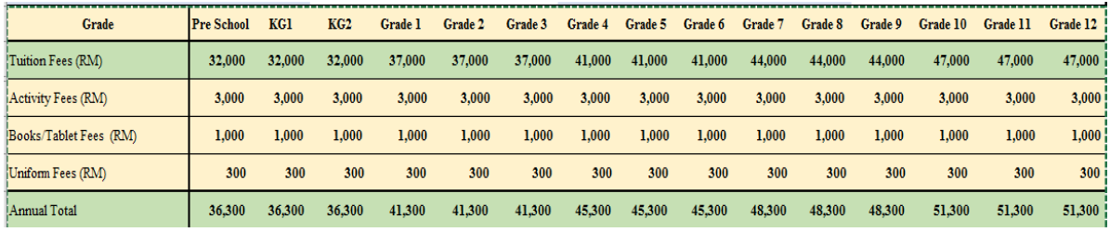

This gridview will saved in the beginning of new year.

**Note: the type of fees is selected automatically from the**

**Account chart under Revenues sub account. Note only account**

**name ending with Fees Revenue will be shown inside grade fees**

**configuration.**

* Change Iqama to visa
* Add more details to the students registration about Father and mother:
* Name Job email Tel Address children account
* Can attached old certificates

**I can’t find this section:**

